2024 Minnesota / Iowa Golf Outing
Monday, August 5th, 2024
Green Lea Golf Course
101 Richway Drive, Albert Lea, MN

4 Person Scramble
10:00am Shotgun Start
Lunch and Awards
Peoria Handicap System
Cost: $70 per player (includes golf, cart, lunch, and prizes)

Name:
Jurisdiction/Firm:
Mailing Address:
Phone Number:
Email Address:
Golfers you wish to be paired with:
Golfer #1
Golfer #2
Golfer #3
** If you do not have a team, but would like to participate, we will find you a group! **

Registration and Payment due by Monday, July 29th, 2024
Please make checks payable to Jason McCaslin
Mail Registration to: Jason McCaslin
1126 Lone Stone Ct SE
Chatfield, MN 55923

A very special Thank You to our Sponsors!
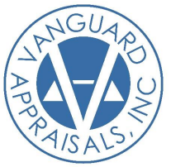










Stay Tuned! Additional Sponsors Pending!

