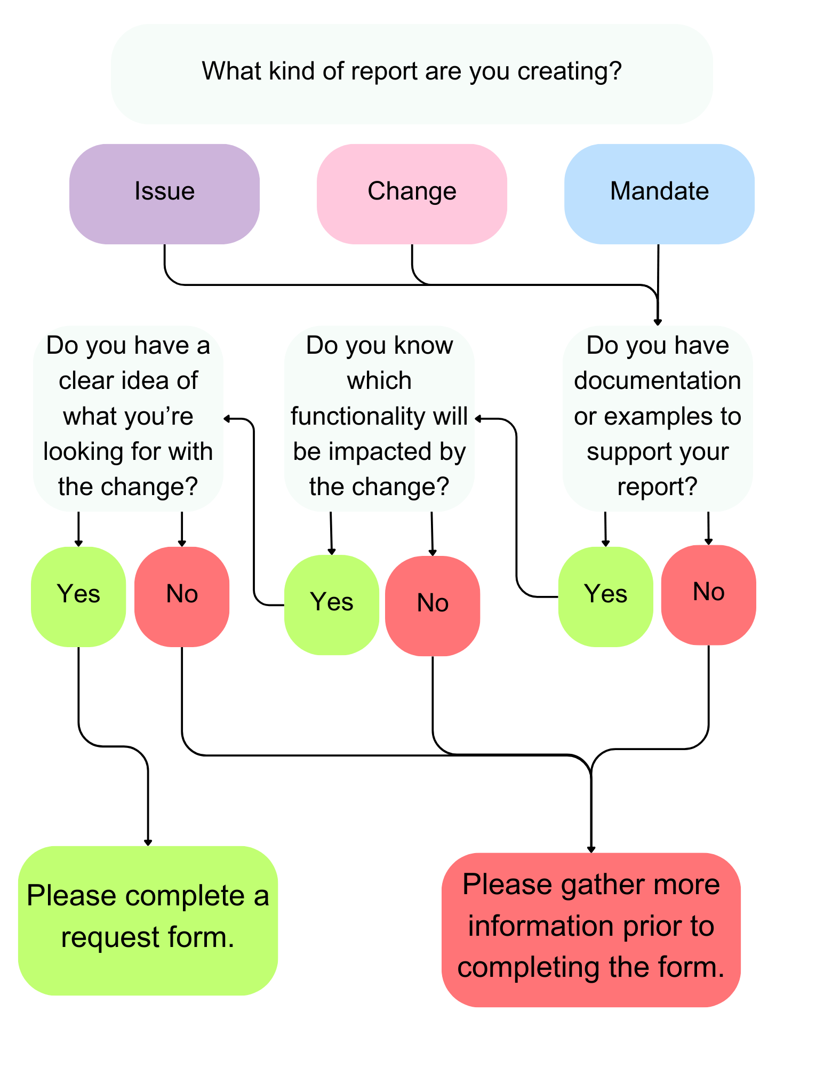
Tyler User Group
Issues and Change Request Form
Adopted by the MnCCC Tyler User Group – August 23, 2023
The purpose of this document is to record and track proposed changes to and/or issues with the Tyler software. Please include a detailed summary of your request or report, along with screenshots, examples, or other pertinent information. Forms received by the first Wednesday of the month will be reviewed at the next Enhancement Committee meeting. Send the completed form to emily@mnccc.gov and lisa@mnccc.gov to begin processing.
- All issues/change requests are to be sent to MnCCC for documentation
- The Tyler Enhancement Committee will review proposed changes and issues, which will be brought to the appropriate committee for further processing
- The Tyler User Group will review the forms and forward the issues/changes to Tyler for final processing
Individual/Committee Submitting Request:  Kayla Pierce |  | County:  Fillmore |  |  | Date of Request:  11/3/23
Email Address:  Kpierce@co.fillmore.mn.us |  | Phone:  5077652670 |  |  | Required Date:  N/A
Priority (Please reference definitions on back of form) | Critical |  | High | Medium |  | Low

Describe the issue(s), change(s), or mandate(s) in as much detail as possible
Add a note box on the Dwelling screen. Link the note boxes to the CAMA notes tab.

What new functionality, or change to existing functionality is being requested? If not a change, which functionality are you having issues with?
The dwelling, additions, OBY, and land screen notes should be linked up to correspond on the CAMA notes tab.
What is the desired result of the change or issue report?
To be able to add a note when on a specific tab but be able to view all notes on CAMA notes tab when looking for information.
Additional information you feel is relevant during the committee’s review of the proposal (Please include screenshots, examples, or other pertinent information detailing desired change and/or issue).

Tyler User Group Chair | Date
This Request has been Approved for Design and Estimate |  | Yes | No

Report Classification Key
Priority | Description | Example
Critical | Enterprise Assessment & Tax software is inoperable for all users in jurisdiction, warranting most timely response. | The Enterprise Assessment & Tax system is down. No users can pull up or log into the iasWorld system.  Classified as CRITICAL priority since the entire system is not usable and impacts all users and all daily functions.
High | Impacts daily processing or day-to-day functions. | Client in the middle of their year-end processes. I began CA400 yesterday afternoon and it is still running as of this morning. Last year, the report only took ~20 minutes to complete.  Classified as HIGH priority because the client is in the middle of a process that impacts some users’ use of the system.
Medium | Impacts small group of users without impacting daily processing. | We have an issue with the sketching program duplicating entries on additions. Screenshot #4 has 3 FOPs showing as triplicated and we only entered it once. The history shows the same time for all 3. Issue is happening intermittently.  Classified as MEDIUM priority because this can impact daily function for a larger set of users, but has been described as intermittent.
Low | Affects one user without impacting daily functioning. | I was creating a new parcel for a Manufactured Home in Assess Admin and put the wrong tax district in the legal tab.  Classified as LOW priority because this is only impacting one parcel and doesn’t interfere with daily processing.

